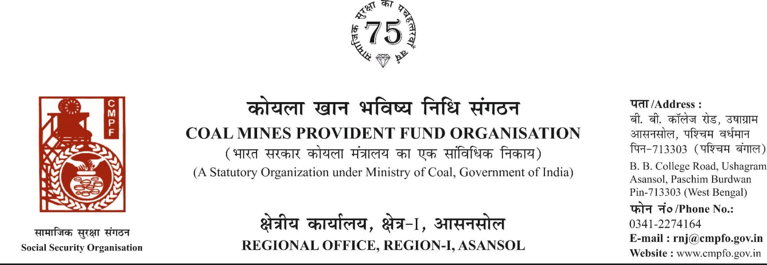

CPF/118/MISC/Extract/Voll-2/R-I/ASN Date-12/08/2025
To,
The Regional Commissioner
Coal Mines Provident Fund Organisation
PO-Jaripatka, Dist-Nagpur -440014
Maharashtra

Sub- Sub- Inter-Regional Extract In-Out
Ref. : CPF/NAG/32/Misc/Extract incoming/748 Dated. : 08/08/2025
Sir,
In view of the revised procedure prescribed in procedure office order No-230 Dated-12/02/1973 of CMPF Commissioner, Dhanbad, I am to state that the ledger card of the following member is forwarded to your office as he is working under jurisdiction of your region.
It is ensured that the posting in the ledger card are dully completed for the periods for which the member was contributing in this region.
SL. No | Name of the member | CMPF A/C No | Name of the colly where member worked in this region | Name o the colliery where member working in your region
1 | Surjit Kumar Goswami | BKR/3/810 | Jhanjra Colliery  (RNJ/38) | EKONA MINE  (NGP/107)

Encl- As above
Yours faithfully

Assistant Commissioner

